**Adventure Works Database Analysis with SQL and Power BI**

***Introduction***

Data analysis is an essential part of modern business, and having the right tools and techniques in place is crucial for making informed decisions. In this blog post, we’ll be showcasing how we used the “*Adventure Works”* database and Power BI to analyze sales, customer, and product data and how these tools can help you achieve similar results in your own data analysis projects.

***SQL***

The Power Behind Data Transformation SQL (Structured Query Language) is a powerful and versatile programming language used to manage and manipulate data stored in relational databases. In our project, we used SQL to *clean and transform* the data from the Adventure Works database before analyzing it in Power BI. By using SQL, we were able to prepare the data for analysis and ensure that it was in the right format for our needs.

***Functions Used in SQL***

The following functions were used in SQL to clean and transform the data:

* AS Statement (Renaming Columns)
* Combining columns using the LEFT JOIN function
* Filtering data using the WHERE Clause
* Sorting data using the ORDER BY clause
* Handling missing or null values with the CASE() and ISNULL() functions

***Power BI***

Visualizing Data Insights Power BI is a business intelligence platform from Microsoft that allows users to create interactive data visualizations, reports, and dashboards. In our project, we used Power BI to create a dashboard to analyze the sales, customer, and product data from the AdventureWorks database. Power BI provides a user-friendly interface and a wide range of visualization options, making it an ideal tool for data analysis.

***Visualizing Data in Power BI***

One of the key benefits of using Power BI is the ability to create *visually engaging charts and graphs to present data insight*s. In our project, we used Power BI’s visualizations to present key insights into sales analysis, customer details, and product details. By using visually appealing charts and graphs, we were able to improve data visibility and user engagement.

***Filters and Budget Comparison Feature***

In addition to creating visualizations, we also included *filters for salespersons and a budget comparison feature* in our Power BI dashboard. These features allowed us to analyze the data more effectively and make informed decisions about our sales strategy. The filters allowed us to focus on specific salespeople, while the budget comparison feature helped us track our sales performance against our budget.

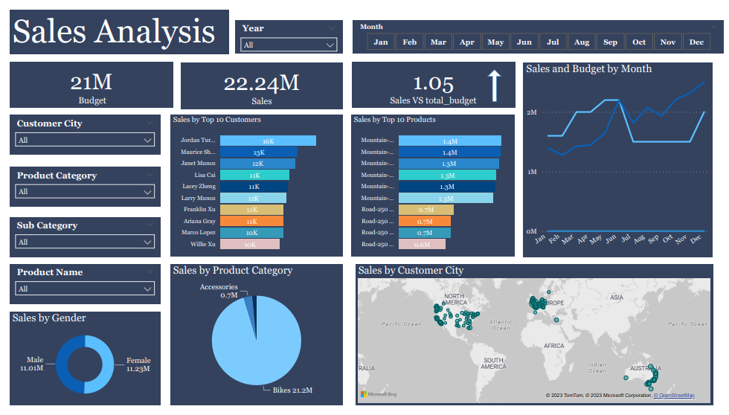

**Sale Analysis Dashboard**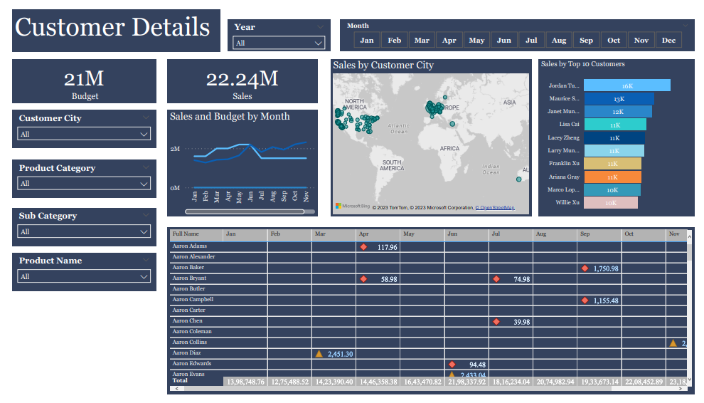

**Customer Details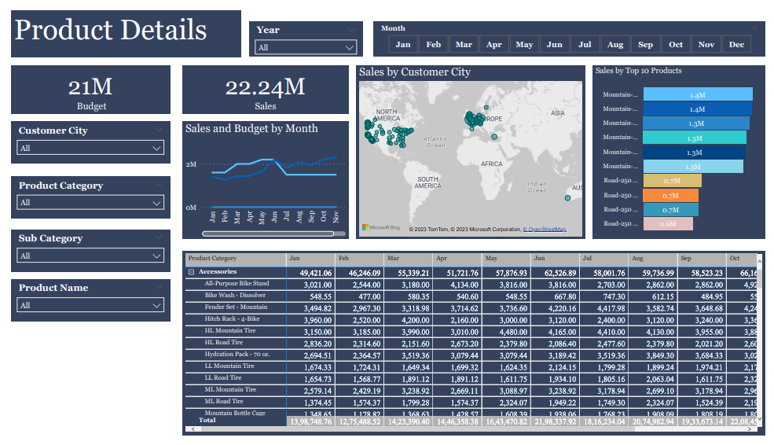Product Details**

***Streamlining the Analysis Process***

By using the Adventure Works database and Power BI, we were able to streamline the analysis process and make better decisions. The clean and transformed data, combined with the visually engaging dashboard, allowed us to quickly see key insights into our sales, customer, and product data, making it easier to make informed decisions.

***Conclusion***

In conclusion, using the AdventureWorks database and Power BI, we were able to clean and transform data, create a visually engaging dashboard, and streamline the analysis process. These tools provide a powerful and user-friendly solution for data analysis and can help you achieve similar results in your own projects. Whether you’re a beginner or an experienced data analyst, the AdventureWorks database and Power BI are an excellent choice for analyzing sales, customer, and product data.